WEEK 5
Date: |  | Day: MONDAY |  |  | Strand: All Around Us
 |  |  |  |  | Sub Strand: Plants
Class: KG 2 |  |  | Class Size:
Content Standard:  K2.6.5.1 Demonstrate understanding of the knowledge that there are different parts of plants and are important sources of food and medicine for other living things. |  |  |  | Indicator:  K2.6.5.1.7 classify different food items into the parts of the plant from which we get it from
PERFORMANCE INDICATOR:  - Learners can draw and label the parts of a plant  - Learners can classify different food items into the parts of the plant from which we get it from. |  |  |  |  | Core Competencies:  Communication and collaboration, Critical thinking, Personal Development and Leadership
Keywords: album,, label, leaves
Reference : KG Curriculum P.g. 173-176
Phase/Duration | Learners Activities |  |  |  |  | Resources
PHASE 1: STARTER | Let learners sing a song in relation to the lesson.  1. Did you enjoy the song?  2. What words did you hear in the song?
PHASE 2: NEW LEARNING  CIRCLE TIME | Teacher, or learner begins by saying "I spy with my little eye something beginning with.....".  The item has to be something within sight of the learners.  Other learners guess until someone guesses correctly. It can also be played with names; "I spy with my little eye someone beginning with..... ".
GROUP ACTIVITY 1  (OUTDOOR) | Learners should go out and observe different types of plants or trees and choose one to draw showing the different parts and labelling them appropriately,  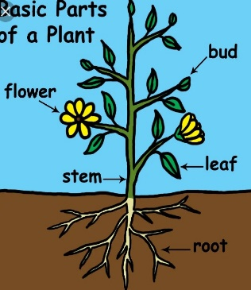  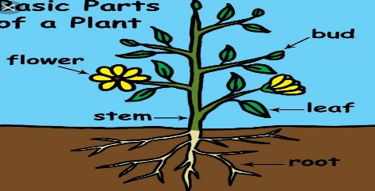  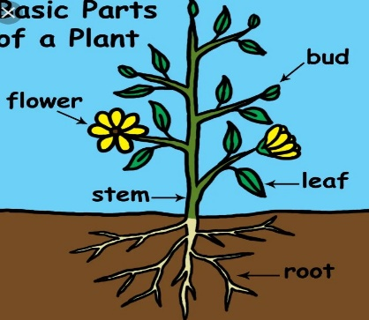  Learner grow different seeds in cans and watch the growth.  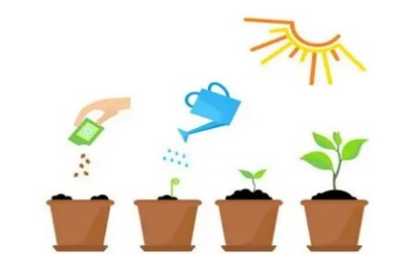  Provide a variety of food items and have the learners sort and classify them into five categories=food from the root, stem, leaves, fruits, or seed.  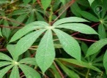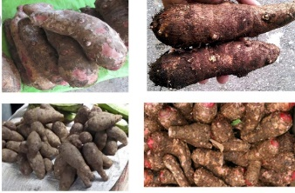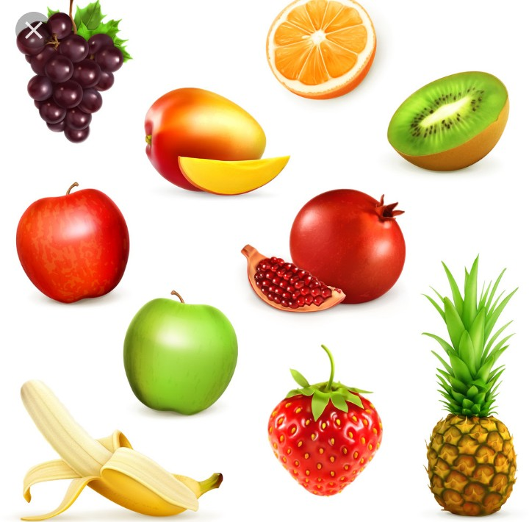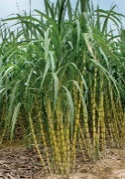  Count the number of objects in each category up to 20.  E.g. guide learners to count the number of food item and pick a numeral card which matches the number quantity  Teach rhymes and songs as learners sing along  Have learners dance with actions as they sing the songs. |  |  |  |  | Sample young plants, pictures, the Big book, pencils and crayons.
PHONICS | Engage learners to sing songs and recite some familiar rhymes that relates to the target sound.  Guide learners to pronounce and write the target sound in the sand tray or exercise books.  Have learners say three or four words that contain the target sound.  Using flash cards, learners read words that contain the target sound.  1. What sound have we learnt today?  2. Which other letter sound do you know?  3. Mention any object in the classroom or home that begins with the target letter sound. |  |  |  |  | Word cards, letter cards.
GROUP ACTIVITY 2  (INDOOR) | Play music and have each learner grab a balloon when the music starts have learners bounce their balloons in the air and move to the music. When the music stops they have to freeze and whoever is holding a balloon “wins.”  Revise names of parts of plant with learners.  Display a picture of a big plant on the board. Point to the roots and ask learners to call out the name.  Repeat the same activity for the stem, leaves and flowers.  Give out different types of leaves to learners to identify their similarities and differences. Eg. some leaves are broad others are tiny.  Ask: Can you identify a plant whose leave you are holding?”  e.g. “Yes this is a mango leaf”.  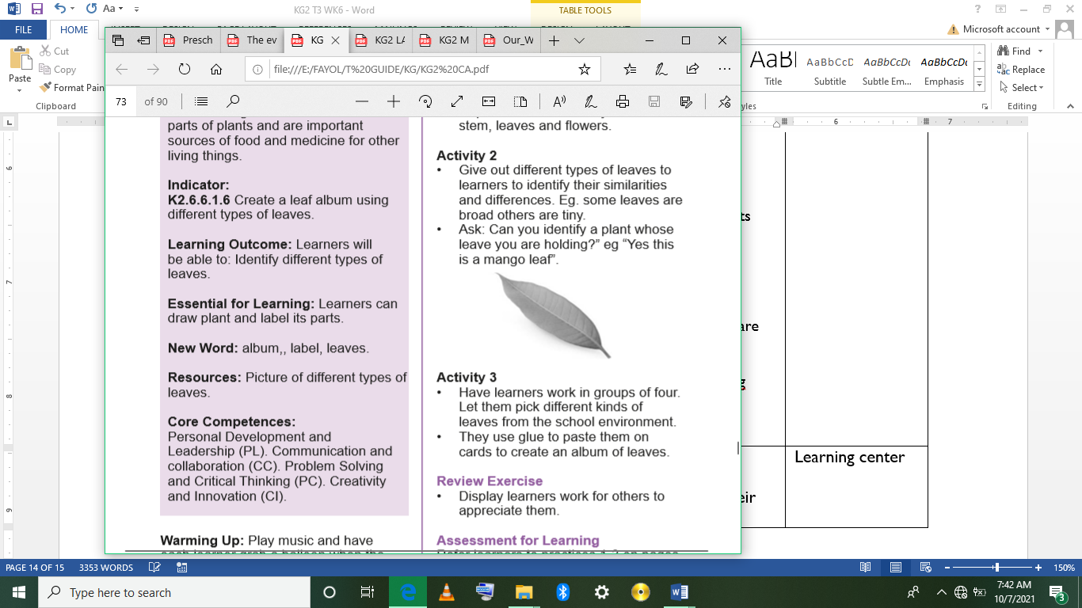  Have learners work in groups of four. Let them pick different kinds of leaves from the school environment.  They use glue to paste them on cards to create an album of leaves.  Assessment  Display learners work for others to appreciate them. |  |  |  |  | Picture of different types of leaves.
LEARNING CENTER | Engage learners to play freely at the learning centers.  Observe, join in and ask learners questions frequently to guide their play and to support their understanding in what they are learning. |  |  |  |  | Learning center
STORY SHARING | Tell learners a story.  Pause regularly and ask questions to make sure learners are following.  Engage learners to act parts of the story.  1. Was the story interesting?  2. What part of the story did you like?  3. what have you learnt from the story? |  |  |  |  | Word cards, letter cards.
PHASE 3: REFLECTION | Learners share what they have learnt with their peers and class.  Give learners homework to do at home.

Date: |  | Day: TUESDAY |  |  | Strand: All Around Us
 |  |  |  |  | Sub Strand: Plants
Class: KG 2 |  |  | Class Size:
Content Standard:  K2.6.5.1 Demonstrate understanding of the knowledge that there are different parts of plants and are important sources of food and medicine for other living things. |  |  |  | Indicator:  K2.6.5.1.6 draw and label the parts of a plant
PERFORMANCE INDICATOR:  - Learners can draw and label the parts of a plant  - Learners can classify different food items into the parts of the plant from which we get it from. |  |  |  |  | Core Competencies:  Communication and collaboration, Critical thinking, Personal Development and Leadership
Keywords: album,, label, leaves
Reference : KG Curriculum P.g. 173-176
Phase/Duration | Learners Activities |  |  |  |  | Resources
PHASE 1: STARTER | Let learners sing a song in relation to the lesson.  1. Did you enjoy the song?  2. What words did you hear in the song?
PHASE 2: NEW LEARNING  CIRCLE TIME | Teacher, or learner begins by saying "I spy with my little eye something beginning with.....".  The item has to be something within sight of the learners.  Other learners guess until someone guesses correctly. It can also be played with names; "I spy with my little eye someone beginning with..... ".
GROUP ACTIVITY 1  (OUTDOOR) | Learners should go out and observe different types of plants or trees and choose one to draw showing the different parts and labelling them appropriately,  Learner grow different seeds in cans and watch the growth.  Provide a variety of food items and have the learners sort and classify them into five categories=food from the root, stem, leaves, fruits, or seed.  Count the number of objects in each category up to 20.  E.g. guide learners to count the number of food item and pick a numeral card which matches the number quantity  Teach rhymes and songs as learners sing along  Have learners dance with actions as they sing the songs. |  |  |  |  | Sample young plants, pictures, the Big book, pencils and crayons.
PHONICS | Engage learners to sing songs and recite some familiar rhymes that relates to the target sound.  Guide learners to pronounce and write the target sound in the sand tray or exercise books.  Have learners say three or four words that contain the target sound.  Using flash cards, learners read words that contain the target sound.  1. What sound have we learnt today?  2. Which other letter sound do you know?  3. Mention any object in the classroom or home that begins with the target letter sound. |  |  |  |  | Word cards, letter cards.
GROUP ACTIVITY 2  (INDOOR) | Play music and have each learner grab a balloon when the music starts have learners bounce their balloons in the air and move to the music. When the music stops they have to freeze and whoever is holding a balloon “wins.”  Revise names of parts of plant with learners.  Display a picture of a big plant on the board. Point to the roots and ask learners to call out the name.  Repeat the same activity for the stem, leaves and flowers.  Give out different types of leaves to learners to identify their similarities and differences. Eg. some leaves are broad others are tiny.  Ask: Can you identify a plant whose leave you are holding?”  e.g. “Yes this is a mango leaf”.  Have learners work in groups of four. Let them pick different kinds of leaves from the school environment.  They use glue to paste them on cards to create an album of leaves.  Assessment  Display learners work for others to appreciate them. |  |  |  |  | Picture of different types of leaves.
LEARNING CENTER | Engage learners to play freely at the learning centers.  Observe, join in and ask learners questions frequently to guide their play and to support their understanding in what they are learning. |  |  |  |  | Learning center
STORY SHARING | Tell learners a story.  Pause regularly and ask questions to make sure learners are following.  Engage learners to act parts of the story.  1. Was the story interesting?  2. What part of the story did you like?  3. what have you learnt from the story? |  |  |  |  | Word cards, letter cards.
PHASE 3: REFLECTION | Learners share what they have learnt with their peers and class.  Give learners homework to do at home.

Date: |  | Day: WEDNESDAY |  |  | Strand: All Around Us
 |  |  |  |  | Sub Strand: Plants
Class: KG 2 |  |  | Class Size:
Content Standard:  K2.6.5.1 Demonstrate understanding of the knowledge that there are different parts of plants and are important sources of food and medicine for other living things. |  |  |  | Indicator:  K2.6.5.1.1. talk freely about different parts of a plants and their uses
Performance Indicator:  - Learners can talk freely about different parts of a plants and their uses |  |  |  |  | Core Competencies:  Communication and collaboration, Critical thinking, Personal Development and Leadership
Keywords: fruits, leaves, roots, stem, plants.
Reference : KG Curriculum P.g. 173-176
Phase/Duration | Learners’ Activities |  |  |  |  | Resources
PHASE 1: STARTER | Let learners sing a song in relation to the lesson.  1. Did you enjoy the song?  2. What words did you hear in the song?
PHASE 2: NEW LEARNING  CIRCLE TIME | Engage learners to play the “Label the Class,” game.  Walk around each learning center with your learners. As they name the items at the various centers, use a permanent marker to write the names on index cards or sentence strips.  Attach them to the item, with tape, in an unobtrusive place.  Each time your child sits on, opens, sleeps in, or otherwise uses one of these items, draw her attention to the card and ask them to read it.  To make the game a little more interesting, you can even ask your learners to use the word in a sentence, such as, “this is Madam’s chair and I’m not supposed to sit in it,” or “I hate to brush my teeth every night!”
GROUP ACTIVITY 1  (OUTDOOR) | Let learners be in a community circle. Let them play: “Pass the ball”.  Put them into groups of five. Give them plants to study. Guide them to identify the different parts. The root, stem, leaves and fruits.  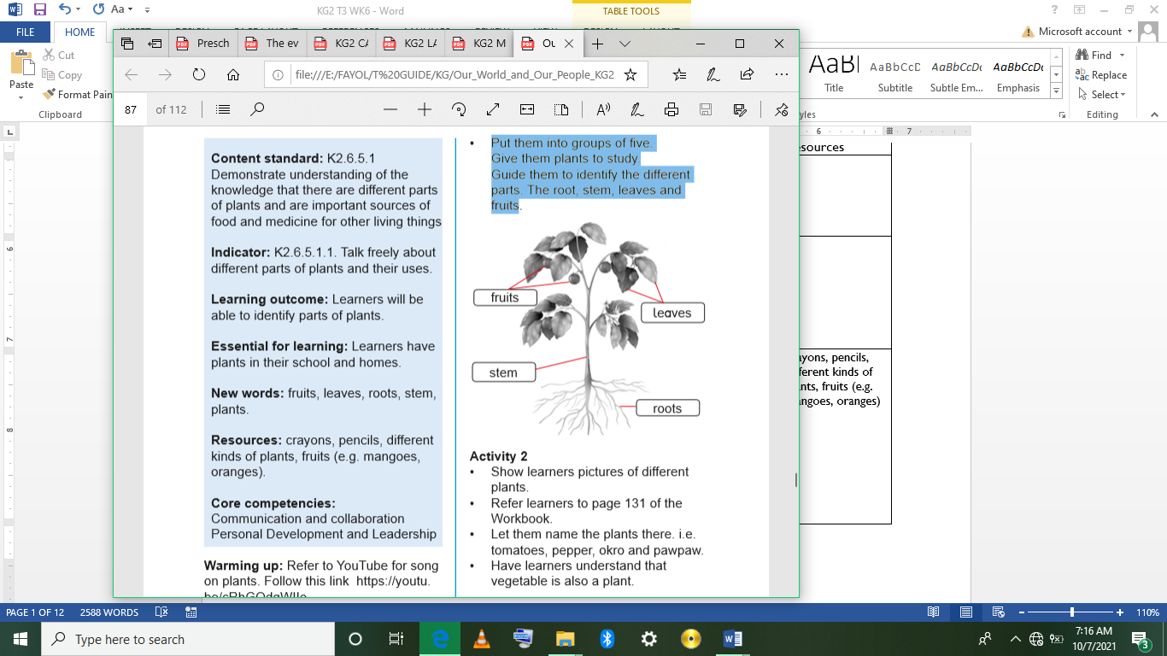  Show learners pictures of different plants. Let them name the plants there. i.e. tomatoes, pepper, okro and pawpaw.  Have learners understand that vegetable is also a plant.  Ask learners to mention some fruits that they know. E.g. oranges, tangerines, mango, apple, pineapple. All these fruits are gotten from plants  Call on learners randomly to answer questions or contribute to the discussion.  Learners observe the pictures of different types of plant and identify their different parts, the root, stem and leaves and fruit, (as it is shown on the conversational poster). and discuss the different parts of plants and food we get from them.  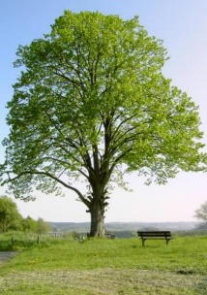  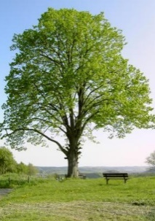  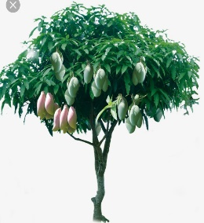  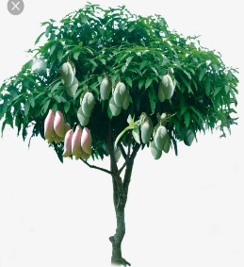  Learners exhibit different parts of plants that we use as food and medicines  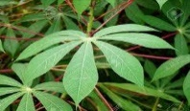  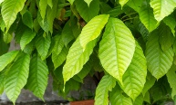  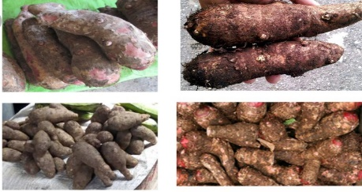  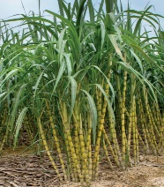  Assessment  Put learners in pairs. Give them an uprooted plant. One person holding the plant points to the stem, and the partner mentions the name, they should do same for all the other parts. |  |  |  |  | crayons, pencils, different kinds of plants, fruits (e.g. mangoes, oranges)
PHONICS | Engage learners to sing songs and recite some familiar rhymes that relates to the target sound.  Guide learners to pronounce and write the target sound in the sand tray or exercise books.  Have learners say three or four words that contain the target sound.  Using flash cards, learners read words that contain the target sound.  1. What sound have we learnt today?  2. Which other letter sound do you know?  3. Mention any object in the classroom or home that begins with the target letter sound. |  |  |  |  | Word cards, letter cards.
GROUP ACTIVITY 2  (INDOOR) | Have learners sing any song song on plant.  Greet learners with a smile and let learners do same with friends. Have learners sit in a semi-circle. Play (pass a ball) game with learners.  Have learners work in pairs. Give them young plants (make sure the plants you uproot are not harmful to learners). Engage learners in active discussions on the theme (plants) by observing them critically.  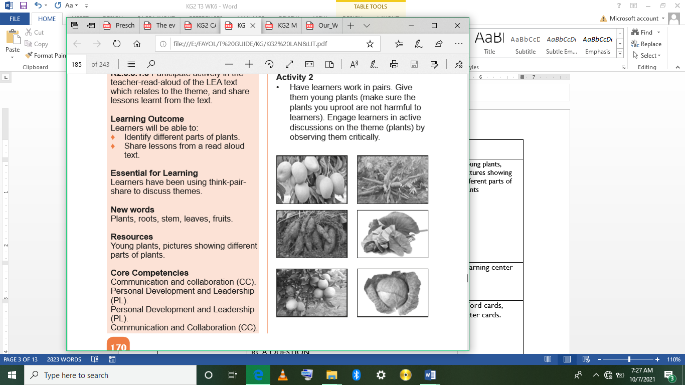  Guide them to identify the  1. The leaves,  2. stem,  3. roots,  4. fruits one by one.  Call on learners randomly to answer questions or contribute to the discussion  E.g. a. Point to the roots.  b. Point to the stem.  c. Which parts is in the soil?  d. Which parts bear fruits?  e. Which parts move when the air is blowing?  Show pictures of different types of plant. Let them identify their different parts e.g. the roots, stem, leaves and flowers/fruits.  Discuss the different parts of plants and the fruits we get from them. e.g.  1. Cassava, yam, cocoyam, carrot from the roots.  2. Oranges, pawpaw watermelon, grapes.  3. Medicine from roots and leaves. |  |  |  |  | Young plants, pictures showing different parts of plants
LEARNING CENTER | Engage learners to play freely at the learning centers.  Observe, join in and ask learners questions frequently to guide their play and to support their understanding in what they are learning. |  |  |  |  | Learning center
STORY SHARING | Tell learners a story.  Pause regularly and ask questions to make sure learners are following.  Engage learners to act parts of the story.  1. Was the story interesting?  2. What part of the story did you like?  3. what have you learnt from the story? |  |  |  |  | Word cards, letter cards.
PHASE 3: REFLECTION | Learners share what they have learnt with their peers and class.  Give learners homework to do at home.

Date: |  | Day: THURSDAY |  |  | Strand: All Around Us
 |  |  |  |  | Sub Strand: Plants
Class: KG 2 |  |  | Class Size:
Content Standard:  K2.6.5.1 Demonstrate understanding of the knowledge that there are different parts of plants and are important sources of food and medicine for other living things. |  |  |  | Indicator:  K2.6.5.1.2 use a variety of new vocabulary learnt about plants to create an informational text for reading using learners  K2.6.5.1.3 participate actively in the teacher-read-aloud of the LEA text which relates to the theme, and share lessons learnt from the text.  K2.6.5.1.4 recognize and read 25% of sight words instantly and automatically
Performance Indicator:  - Learners can use a variety of new vocabulary learnt about plants to create an informational text for reading using learners  - Learners can participate actively in the teacher-read-aloud of the LEA text which relates to the theme, and share lessons learnt from the text |  |  |  |  | Core Competencies:  Communication and collaboration, Critical thinking, Personal Development and Leadership
Keywords: Plants, roots, leaves, stem.
Reference : KG Curriculum P.g. 173-176
Phase/Duration | Learners Activities |  |  |  |  | Resources
PHASE 1: STARTER | Let learners sing a song in relation to the lesson.  1. Did you enjoy the song?  2. What words did you hear in the song?
PHASE 2: NEW LEARNING  CIRCLE TIME | Engage learners to play the “Sight word wall ball” game.  Use the markers to write 20-25 sight words on index cards.  Attach the index cards to an outside wall using masking tape, or to an inside wall using painter’s tape. Tape them far enough apart both horizontally and vertically that it’s easy to see which word your learners is aiming at.  Call out one of the words. When your learner locates the word on the wall, let him throw the ball at the correct card. Repeat this until he’s had a chance to try hit all of the words.  Next, let your learner decide which words to aim at. Have him point to and read a word and try to hit it with the ball.
GROUP ACTIVITY 1  (OUTDOOR) | Using the Language Experience Approach (LEA), create an informational text on Plants give us Food and Medicine.  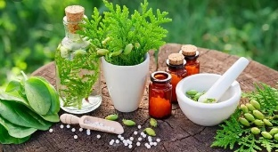  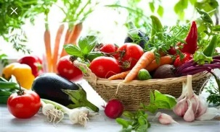  Learners observe the conversational poster # 19, On the farm and with leading questions, have them create and dictate simple sentences orally and the teacher writes the story for them.  Add few more contents and copy onto a big sheet and use that as a reading text.  Follow the steps of the KWL strategy instruction as you read aloud the informational text on the uses of plants to the learners.  Pause often and let learners find answers to their questions.  Learners first say what they know about plants(K),  Ask questions on what they want to know,  Have learners listen to the text and answer their own questions during the reading and share what they have learnt about the parts of a plant and their uses after the reading.  Revise reading the sight words with learners e.g. go, to, in the, come, on, can. Divide the class into groups of five.  Give out the sight words cards for learners to practice reading in their groups.  Play: “Ladder sight words game” Draw a grid and write common sight words on the floor in the classroom or outside.  good the In boy  sister dad Come air  to o Mom girl  in he She water  Divide the class into four groups (depending on the number of learners in your class).  Read the sight word aloud and call on the groups to send a learner to hop on the word on the floor and read it aloud. If the learner is correct, the group gets a point. If nobody gets it correct, demonstrate and hop on the grid. No one get a point  Assessment  Put learners in groups of five. Give each group eight sight words cards for learners to read them |  |  |  |  | Sample young plants, pictures, the Big book, pencils and crayons.
PHONICS | Engage learners to sing songs and recite some familiar rhymes that relates to the target sound.  Guide learners to pronounce and write the target sound in the sand tray or exercise books.  Have learners say three or four words that contain the target sound.  Using flash cards, learners read words that contain the target sound.  1. What sound have we learnt today?  2. Which other letter sound do you know?  3. Mention any object in the classroom or home that begins with the target letter sound. |  |  |  |  | Word cards, letter cards.
GROUP ACTIVITY 2  (INDOOR) | As usual, put learners in a community circle. Let them sing the song on plants, clap their hands and dance as well.  Display the roots (cassava, yam, sweet potatoes), fruits (oranges, grapes), leaves on the table.  Call one learner to come and group them into three. i.e. fruits, roots and vegetables.  Show pictures of roots which have produced food to them. Let them touch the yam, cassava and the sweet potatoes.  Deduce from them where we get them from (i.e. from the roots of plants)  Put the vegetables and the fruits on learners table. Let them work in groups of six. They examine and talk about how we get these from. (from plants).  Let them know that some plant makes flowers and the flowers turn to vegetables and fruits.  Give them the leaves to observe. Let them tell you the uses. E.g. Some leaves are used as medicine.  Have learners hold their chairs. Ask them which part of the plant we got it from. (from the stem of plants) so the tables, doors, wooden spoons, etc. are from plants.  Assessment  Put learners into groups of four. Each person mentions two things we get from leaves, stem and root
LEARNING CENTER | Engage learners to play freely at the learning centers.  Observe, join in and ask learners questions frequently to guide their play and to support their understanding in what they are learning. |  |  |  |  | Learning center
STORY SHARING | Tell learners a story.  Pause regularly and ask questions to make sure learners are following.  Engage learners to act parts of the story.  1. Was the story interesting?  2. What part of the story did you like?  3. what have you learnt from the story? |  |  |  |  | Word cards, letter cards.
PHASE 3: REFLECTION | Learners share what they have learnt with their peers and class.  Give learners homework to do at home.

Date: |  | Day: FRIDAY |  |  | Strand: All Around Us
 |  |  |  |  | Sub Strand: Plants
Class: KG 2 |  |  | Class Size:
Content Standard:  K2.6.5.1 Demonstrate understanding of the knowledge that there are different parts of plants and are important sources of food and medicine for other living things. |  |  |  | Indicator:  K2.6.5.1.5. blend the letter-sound learnt so far into syllables, read and write the syllables boldly and legibly in their books.
Performance Indicator:  - Learners can blend the letter-sound learnt so far into syllables, read and write the syllables boldly and legibly in their books. |  |  |  |  | Core Competencies:  Communication and collaboration, Critical thinking, Personal Development and Leadership
Keywords: Plants, roots, leaves, stem.
Reference : KG Curriculum P.g. 173-176
Phase/Duration | Learners Activities |  |  |  |  | Resources
PHASE 1: STARTER | Let learners sing a song in relation to the lesson.  1. Did you enjoy the song?  2. What words did you hear in the song?
PHASE 2: NEW LEARNING  CIRCLE TIME | Engage learners to play “Step forward” game.  Learners stand at the start line. Teacher calls out 'if you have a /t/ in your name step forward' or 'if your name begins with /f/ step forward'.  The person to get to the finish line wins.
GROUP ACTIVITY 1  (OUTDOOR) | Teach the letter sounds for the week.  Rapidly revise the letter sounds learnt so far.  Revise blending one syllabic words as was done the previous week using pupils blending game.  Teach learners to blend monosyllabic words to form two syllabic words. e.g. Ko-fi letter sound to form two syllabic words. E.g., gogo, te-do(tedo), to-lo(tolo), ba-ba (baba) A-ma.  Call to the front and give one- syllabic word each to 2 learners.  game  eat  lake  name  Upon prompting, let them practice creating many mono-syllabic words by gradually moving towards each other sounding out the single syllabic words separately until they come together, put the two syllables together and sound them as one word.  Call on many other learners to practice putting together two monosyllabic words to become one word. (Ko+ fi=kofi, a+fi =afi. Ma+ma =Mama).  Use the Pupils blending process as found in K2. 6.3.1.4 |  |  |  |  | Sample young plants, pictures, the Big book, pencils and crayons.
PHONICS | Engage learners to sing songs and recite some familiar rhymes that relates to the target sound.  Guide learners to pronounce and write the target sound in the sand tray or exercise books.  Have learners say three or four words that contain the target sound.  Using flash cards, learners read words that contain the target sound.  1. What sound have we learnt today?  2. Which other letter sound do you know?  3. Mention any object in the classroom or home that begins with the target letter sound. |  |  |  |  | Word cards, letter cards.
GROUP ACTIVITY 2  (INDOOR) | Take learners outside for “Natures walk”.  Tell them we are going to observe trees and young plants outside.  Let them observe some young and big trees around.  Ask them to up-root some of the young plants. Assist those who cannot pull or better still uproot a lot of young plants for each learner.  Pair learners and give each pair a plant. Ask learners to observe and talk about the plants.  Let them touch and feel the plants.  Note: Be careful of the plants that you give them. Remember the learners have to wash their hands thoroughly with soap under running water after the lesson.  Display a picture of a big plant on the board. Point to the parts one by one and tell learners their names.  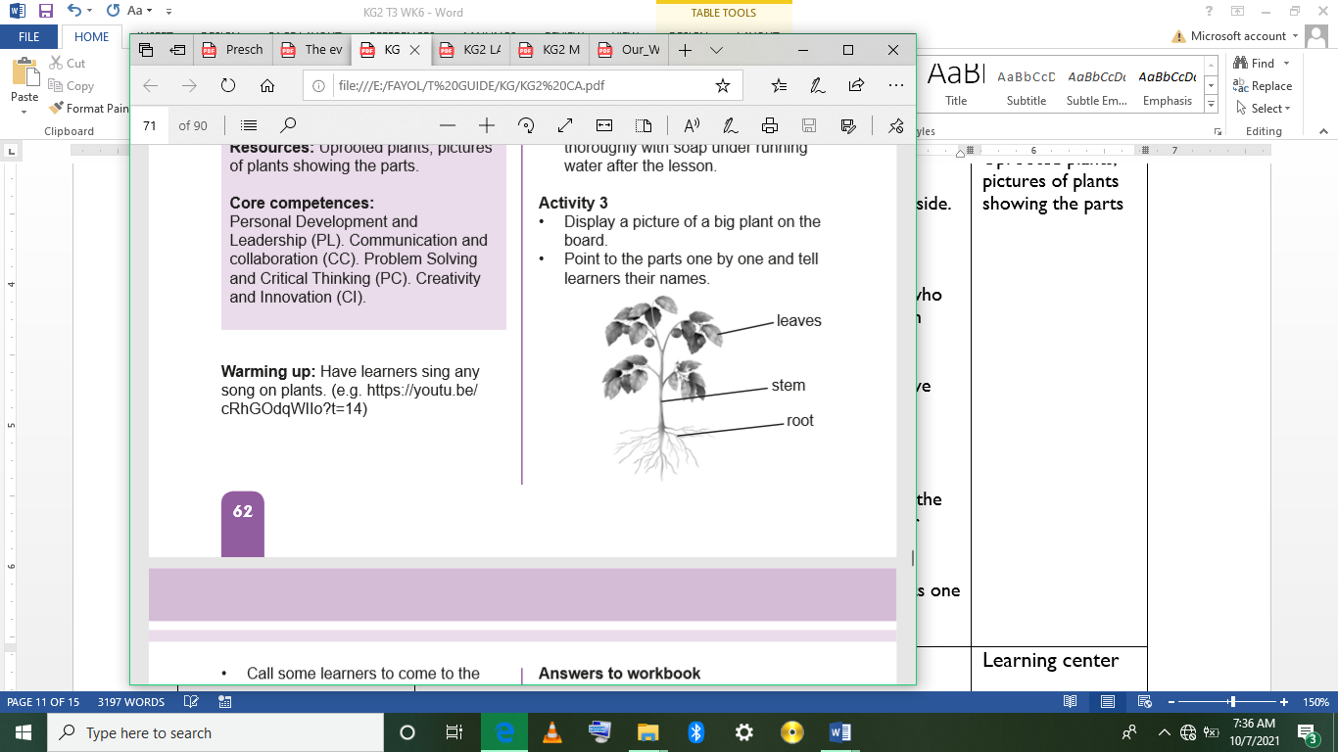  Call some learners to come to the board. Hold a part and they call out its name.  Assessment  Have learners work in pairs. One calls out a part of a plant and the partner touches that part |  |  |  |  | Uprooted plants, pictures of plants showing the parts
LEARNING CENTER | Engage learners to play freely at the learning centers.  Observe, join in and ask learners questions frequently to guide their play and to support their understanding in what they are learning. |  |  |  |  | Learning center
STORY SHARING | Tell learners a story.  Pause regularly and ask questions to make sure learners are following.  Engage learners to act parts of the story.  1. Was the story interesting?  2. What part of the story did you like?  3. what have you learnt from the story? |  |  |  |  | Word cards, letter cards.
PHASE 3: REFLECTION | Learners share what they have learnt with their peers and class.  Give learners homework to do at home.

